Computer Operation Procedure Manual
on
Data Management System
for

Buildings Energy Efficiency Ordinance

for

Energy Efficiency Office

of

Electrical and Mechanical Services Department (EMSD)

By


Version: 0.1

July 2022

© The Government of the Hong Kong Special Administrative Region
The contents of this document remain the property of and may not be reproduced in whole or in part without the express permission of the Government of the HKSAR.

Distribution
Copy No. | Holder
1 | Electrical and Mechanical Services Department (EMSD)
2 | Automated Systems (HK) Limited (ASL)

Prepared By:  Christine LAM  Automated Systems (HK) Ltd.  [Project Manager] | Endorsed By:  Kenneth Fung  Electrical and Mechanical Services Department  [EE/ITD/3]
Date: | Date:

Amendment History
Change Number | Revision Description | Section Affected | Revision Number | Date
1 | Draft Version | All | 0.1 | 06/07/2022

Table of Contents

1. Purpose 5
2. Scope 6
3. Reference 7
4. Definitions and Conventions 7
4.1 Definitions 7
4.2 Conventions 7
5. Computer System Information 8
5.1 Hardware Configuration 9
5.2 Communication Network Configuration 10
5.3 Other Hardware Components Description 11
5.3.1 San storage 11
5.3.2 San Switch 11
5.3.3 Lan Switch 11
5.3.4 iPad 11
5.3.5 Computer Equipment Rack 11
5.4 System Software Environment 12
5.4.1 Application Software 12
6. Computer System Operating (Normal) 13
6.1 Turning ON/OFF The Servers 13
6.1.1 Turn Off the Servers 13
6.1.2 Backup Job 14
6.1.3 Turn On the Servers 14
6.2 Switching ON/OFF the Hardware Components 14
6.3 Loading the Computer System 15
6.3.1 Load Services on Application Server 15
6.3.2 Load Services on Database Server 15
6.4 Shutting Down the Computer Systems 15
6.4.1 Shut Down Services on Application Server 16
6.4.2 Shut Down Services on Database Server 16
6.5 Scheduling 16
6.5.1 Backup Jobs 16
6.5.2 Schedule Jobs 16
6.6 Media Placement 17
6.7 System Monitoring Tasks 17
6.7.1 Ensure Services Running in Windows 2019 Servers 17
6.7.2 Monitor Disk Space Utilization in Windows 2019 Servers 18
6.7.3 Inspect Events in Windows 2019 Servers 19
6.7.4 System Performance Monitoring in Windows 2019 Servers 20
6.8 Scan Virus 21
6.9 Other System Operations 22
6.9.1 Change Server Password 22
7. Computer System Operating (Abnormal) 23
7.1 Power Supply System Outage 23
7.2 Fault Report Procedure 23
7.3 First Line System Crash/Communication Faults Diagnosis 24
7.3.1 System Crash Diagnosis Procedure 24
8. Computer System Operating (Restart) 25
8.1 Reloading Procedures 25
9. Removable Media handling 26
9.1 Tape Deck Handling 26
9.2 Backup Tapes 26
9.3 MAGNETIC TAPE FAILURE RECOVERY/REPORTING 26
9.4 Labelling of Magnetic Tapes 27
9.4.1 Backup Tapes 27
9.5 Off-Site Tape Aarrange 27

Purpose

The purpose of this is to provide information and operating instructions related to the operating of the computer systems, BEEO-DMS system.

Scope
This document defines the computer operating procedures manual for (DMS-BEEO). It should be reference for all operation staff involved in (DMS-BEEO) operation.

Reference
Documentation Standards for Implementation Phase (S8)

Definitions and Conventions

Definitions
DMS | Data Management System
DB | MS SQL Database
Rptserv | MS SQL Report Server
LN | Lotus Notes
IP | Internet Protocol
LAN | Local Area Network
VM | Virtual Machine
SAN | Storage Area Network
iDRAC | Integrated Dell Remote Access Controllers

Conventions
NIL

Computer System Information
This section mentions the system information for the computer systems, including:

- Hardware Configuration
- Communication Network configuration
- Hardware Components Description
- System Software Environment
- Application Software

Hardware Configuration
This section describes the virtual machine for application servers, database servers, the VMware vSphere physical machines, network equipment to be required by the system.

Hardware Item | Host Name/  Item No. | Description | Machine Type  (Physical/  Virtual) | Location
VMware vSphere server | server01 | HP ProLiant DL380 Gen10 | Physical | 1/F Watson Centre, Kwai Chung
  Item | Description
  OS | VMWare ESXi 6.7
  CPU | Intel Xeon Gold 6134
  RAM | 128 GB
  DISK | 15TB in RAID 6
VMware vSphere server | server02 | HP ProLiant DL380 Gen10 | Physical | 1/F Watson Centre, Kwai Chung
  Item | Description
  OS | VMWare ESXi 6.7
  CPU | Intel Xeon Gold 6134
  RAM | 128 GB
  DISK | 15TB in RAID 6
Backup Server | beeoba01 | HP ProLiant DL380 Gen10 | Physical | 1/F Watson Centre, Kwai Chung
  Item | Description
  OS | VMWare ESXi 6.7
  CPU | Intel Xeon Silver 4108
  RAM | 64 GB
  DISK | 11TB in RAID 6
Application Server (production) | beeodmsapp |  | Virtual | Server02
  Item | Description
  OS | Microsoft Windows Server 2019 Standard
  OS Version | 10.0.17763 Build 17763
  VM | VMware 7
  CPU | Intel Xeon Gold 6134
  RAM | 32 GB
  DISK | 600 GB
Database Server (production) | beeodmsdb |  | Virtual | Server02
  Item | Description
  OS | Microsoft Windows Server 2019 Standard
  OS Version | 10.0.17763 Build 17763
  VM | VMware 7
  CPU | Intel Xeon Gold 6134
  RAM | 32 GB
  DISK | 1.3 TB
Application Server (Development) | beeodmsdev |  | Virtual | Server01
  Item | Description
  OS | Microsoft Windows Server 2019 Standard
  OS Version | 10.0.17763 Build 17763
  VM | VMware 7
  CPU | Intel Xeon Gold 6134
  RAM | 32 GB
  DISK | 1 TB
Database Server (Development) | beeodmsdev |  | Virtual | Server01
  Item | Description
  OS | Microsoft Windows Server 2019 Standard
  OS Version | 10.0.17763 Build 17763
  VM | VMware 7
  CPU | Intel Xeon Gold 6134
  RAM | 32 GB
  DISK | 1 TB
LAN Switch |  |  | Physical | 1/F EMSD HQ
Computer Equipment Rack |  |  | Physical | 1/F EMSD HQ
iPad |  |  | Physical | M/F EMSD HQ

Communication Network Configuration
This section describes the configuration setting of all servers for connection to EMSD departmental network
IP | Host Name | Description | Machine Type  (Physical/Virtual)
10.16.133.22 | server01 | VMware vSphere server | Physical
10.16.133.23 | server02 | VMware vSphere server | Physical
10.16.133.32 | beeoba01 | Backup Server | Physical
10.16.133.214 | beeodmsapp | Application Server (production) | Virtual
10.16.133.215 | beeodmsdb | Database Server (production) | Virtual
10.16.133.216 | beeodmsdev | Application Server (Development) | Virtual
10.16.133.216 | beeodmsdev | Database Server (Development) | Virtual

Other Hardware Components Description
    - San storage

The san storage holds the data stores for the VM machine.

    - San Switch

The san switch allows many to many communications between the san storage and the other server through optical fibre channel protocol.

    - Lan Switch

The Lan switch allows many to many communications between system and EMSD departmental network.

    - iPad

The mobile device used for mobile inspection.

    - Computer Equipment Rack

The standard 19-inch rack is a standardized frame for mounting multiple equipment modules and servers.

System Software Environment
    - Application Software

Device/ Host Name | Software ID/Name | Version / Release no. | Description
beeodmsapp | Windows 2019 Server standard | 10.0.17763 Build 17763 | Operation system
beeodmsapp | Symantec Endpoint Protection | 14 build 1148 | Anti-Virus
beeodmsdb | Windows 2019 Server standard | 10.0.17763 Build 17763 | Operation system
beeodmsdb | SQL Server 2017 | (RTM-CU28) (KB5008084) - 14.0.3430.2 (X64) | Database software
beeodmsdb | Symantec Endpoint Protection | 14 build 1148 | Anti-Virus
beeodmsdev | Windows 2019 Server standard | 10.0.17763 Build 17763 | Operation system
beeodmsdev | SQL Server 2017 | (RTM-CU28) (KB5008084) - 14.0.3430.2 (X64) | Database software
beeodmsdev | Symantec Endpoint Protection | 14 build 1148 | Anti-Virus

Computer System Operating (Normal)
This section mentions the operating procedures of performing the following tasks for operating staff under the computer systems, web-based BEEO-DMS system, including:

  - Turning On/Off the Servers
  - Switching On/Off the Hardware Components
  - Loading the Computer Systems
  - Shutting Down the Computer Systems

Turning ON/OFF The Servers
    - Turn Off the Servers
Before turning off the servers, operating staff is required to check whether the backup jobs (For more details, please refer to Section Error: Reference source not found) related to that server are being run or not.

After operating staff has verified that there are no backup job(s) related to that server being run, operating staff is required to follow the steps below in order to turn off the servers:

- Login the server.
- Click the “Start” button from the menu of the network operating system
- Select “Shutdown”

Below is the screen shown after the above procedures have been performed.
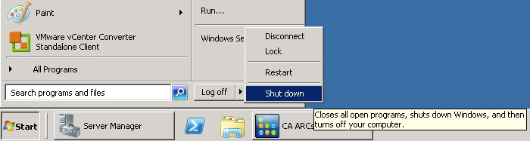
    - Backup Job
In order to check whether the backup job(s) is/are running on the Backup server, operating staff is required to check the Job Status of the Tape Backup Software, BackupExec, on the backup server.

It is recommended NOT to turn off the servers when there is/are backup job(s) being run on that server. Otherwise, data may be lost owing to the incomplete running of the backup job(s).
    - Turn On the Servers
To turn on the servers, operating staff is required to press the “Power” button of the server. The location of the “Power” button is subject to the model of the server. Operating staff may refer to the specification of the servers.

After the “Power” button of the server has been pressed, the Windows operating system will be loaded. After the operating system has been loaded, operating staff is required to perform the procedures mentioned below:

- Login the server as Administrator
- Load the services on the servers (Refer to Section Error: Reference source not found for more details)
- Press Lock the Console for Secure Console from any unauthorized access.

Note: A visit to the server room is required to accomplish the task of turning on the servers.

Switching ON/OFF the Hardware Components
Before switching on/off other hardware components (like Tape Drive etc.), in general, operating staff is required to seek approval from the responsible parties so as to access the physical location of the hardware components. Access card(s)/key(s) may be required to access the server room and the cabinet where the hardware components are placed.

In order to switch on/off the hardware components, operating staff is required to press the “Power” buttons of the hardware components. The locations of the “Power” buttons are subject to different models of the hardware components. Operating staff may also need to configure the software related to that hardware components. Please refer to the specification of the hardware components for further details.

Loading the Computer System
In case there is any maintenance on the system, some of the servers are required to perform manual loading or shutting down. Operating staff is required to perform the procedures mentioned below to perform manual loading of the services.
    - Load Services on Application Server
In order to load the services on Application server, operating staff is required to follow the procedures mentioned below:

  - Login as Administrator
  - Ensure the service “World Wide Web Publishing Service” is started
  - Logout from the server

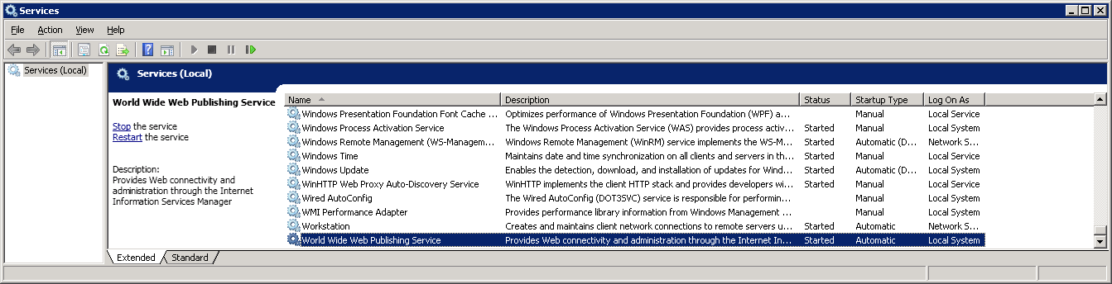
    - Load Services on Database Server
In order to load the services on Database server, operating staff is required to follow the procedures mentioned below:

  - Login as Administrator
  - Ensure the services for SQL server are started
  - Logout from the server
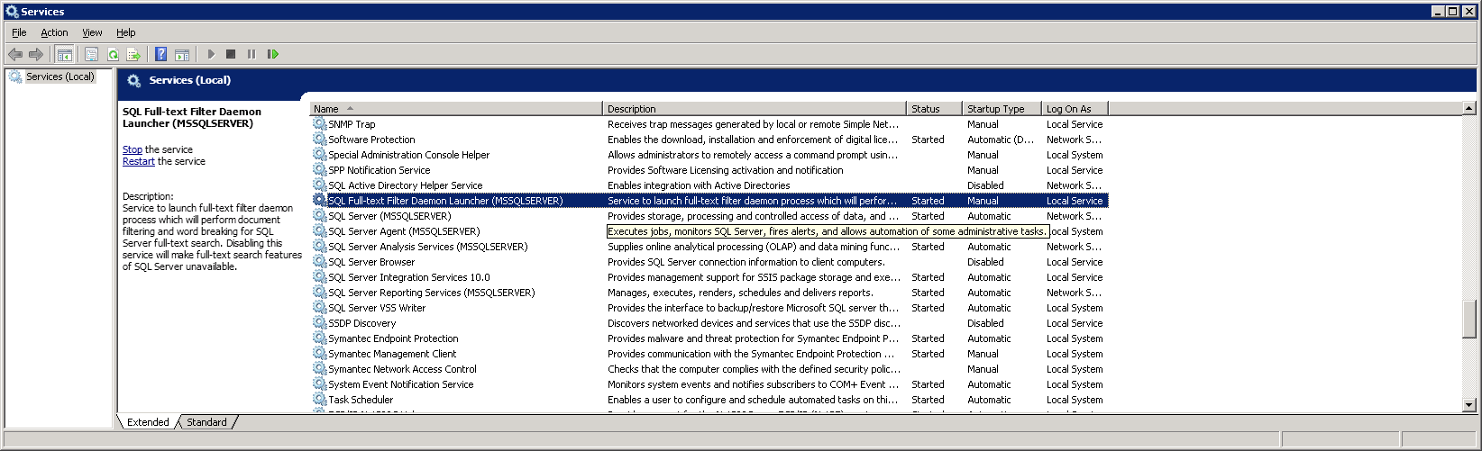

Shutting Down the Computer Systems
In case there is any maintenance on the system, some of the servers are required to perform manual loading or shutting down. Operating staff is required to perform the procedures mentioned below to perform manual shutting down of the services.

    - Shut Down Services on Application Server
In order to shut down the services on Application server, operating staff is required to follow the procedures mentioned below:

  - Login as Administrator
  - Stop the service “World Wide Web Publishing Service”
  - Logout from the server

    - Shut Down Services on Database Server
In order to shut down the services on Database server, operating staff is required to follow the procedures mentioned below:

  - Login as Administrator
  - Stop the services for SQL server are started
  - Logout from the server

Scheduling
    - Backup Jobs
Backup job of BackupExec on Backup server is scheduled to run periodically.

    - Schedule Jobs
The schedule jobs are listed in the table below whereas they are executed by BEEO-DMS application:

Job Name | Program description
BJ_Checklist_MobileList | To generate mobile inspection checklist.
BJ_LetterAction | To generate letters in batch.
WBRS_data_sync | To synchronize e-submission data to BEEO-DMS.
WBRS_file_sync | To synchronize e-submission attachment files to BEEO-DMS.
BEEOGENREPORT | To generate reports periodically.
BJ_SendElicenceEmail | To send email with E-Licence as attachment to applicant and inform related parties.

Media Placement
1 set of backup tapes of weekly full backup shall be kept off-site (Data Center at Siu Ho Wan) with the conditions supporting the storage of backup tapes. The sets of tapes will be call back when the set of tapes which are going to be used again.

System Monitoring Tasks
    - Ensure Services Running in Windows 2019 Servers
In order to check the status of the services, operating staff is required to perform the following steps:

  - Select “Start” from the lower left-hand corner of the console
  - Select “Administrative Tools”
  - Select “Services”

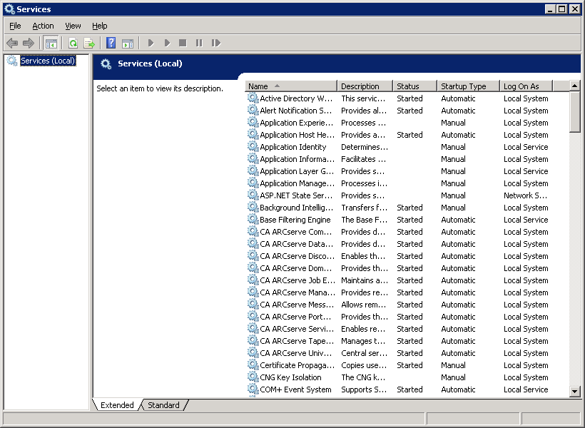

Operating staff can ensure the services are automatically initiated by verifying their statuses (“狀態”) are started (“啟動”).

If the system services are not started, operation staff can start the services by right-click on the services and choose “Start” (“啟動”).

To stop a system services, operation staff can start the services by right-click on the services and choose “Stop” (“停止”).

    - Monitor Disk Space Utilization in Windows 2019 Servers
To observe the disk space utilisation, operating staff is required to perform the following steps:

  - In desktop, place the mouse cursor over the icon “Computer” and then right-click to select “Open”. A window of file explorer will be shown as follows:

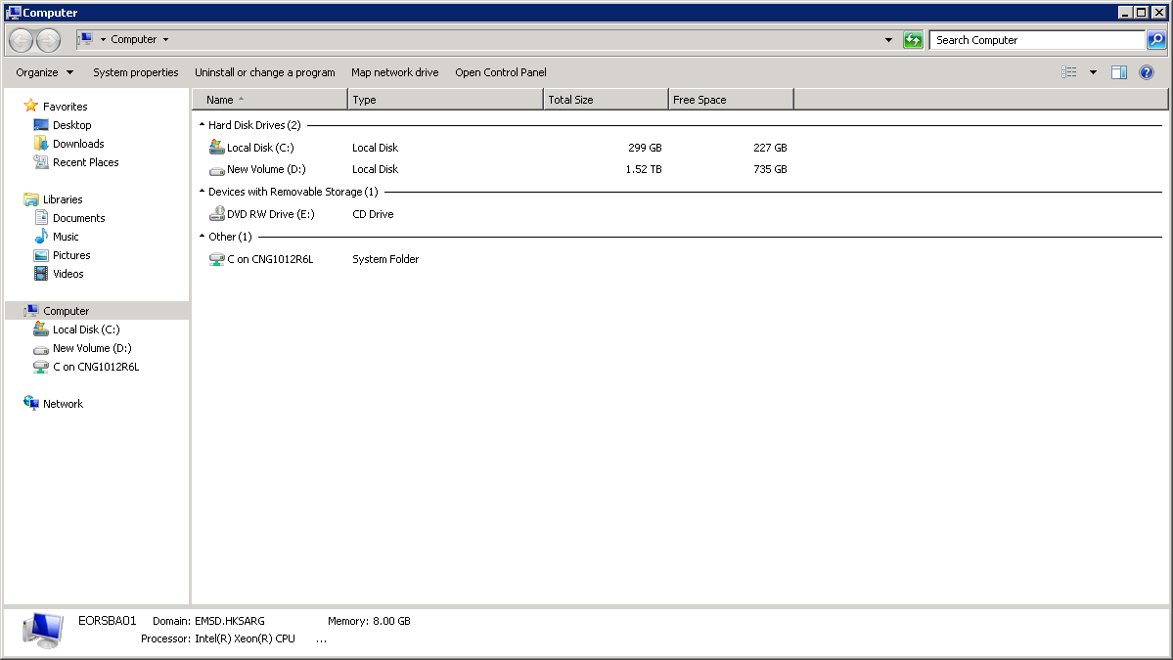

  - The total disk capacity assigned to each drive is shown in the column “Total Size”. And the disk free space is shown in the column “Free Space”. (In the above example, Drive (C:) has the disk capacity of 299GB and remains 227GB of free storage).
An appropriate disk cleaning up should be performed if free storage is less than 10% of total disk capacity. Or management team should be notified if hardware upgrade is necessary.
  - To view the disk usage of a particular folder, place the mouse cursor over the selected folder and right-click to select “Properties”.
The following properties window will be shown:

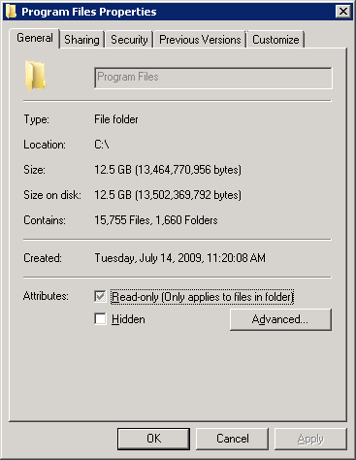

  - The folder size is shown at “Size:”. (In the above example, the “Program Files” folder occupied in Drive (C:) with a space of 12.5GB)

    - Inspect Events in Windows 2019 Servers
To view the system event log, operating staff is required to perform the following steps:

  - Select “Start” from the lower left-hand corner of the console
  - Select “Administrative Tools”
  - Select “Event Viewer”

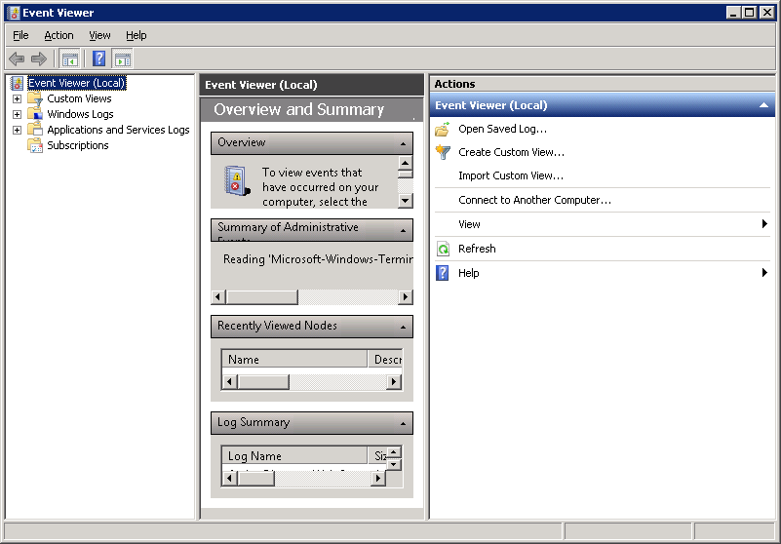

  - Operating staff must observe regularly the system log and application log by selecting “Application” and “System” of “Windows Logs” respectively.
  - Operating staff should particularly look into the event with or indicated in the column “類型” and report to application support team accordingly.

    - System Performance Monitoring in Windows 2019 Servers
Follow the steps below to invoke the graphical presentation of the current system usage information:

  - Right-click on the task bar and select “Task Manager…”
  - Windows Task Manager will be displayed as shown

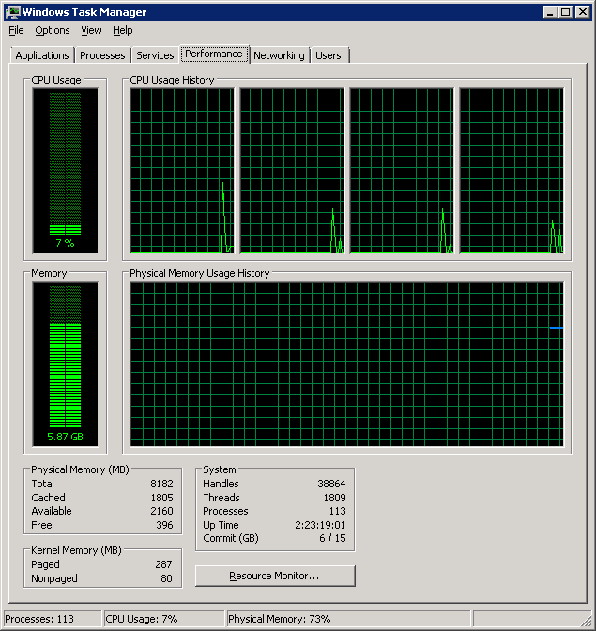

From the tab Performance, it will show the current usage of CPU and Memory. When a high and steady line is found in CPU Usage History, it may indicate the server is in a very busy moment. If this situation keeps for a period of time, say for 5 minutes, support team should be notified.

Scan Virus
With a view to guard against virus intrusion to the system and system users, the application will perform virus scanning on data files and make sure they are clean before uploading them. The scanning activity is scheduled by group policies, as well as virus signature update.

Other System Operations
    - Change Server Password
In order to change the password of the GIS server, Report server, Image server, or Backup server, operating staff is required to perform the procedures mentioned below:

- Log on the Server
- Click the “Start” button in the lower left-hand corner on the screen
- Select the icon “Administrative Tools”
- Select the icon “Computer Management”
- Double-click “Local Users and Groups”
- Choose “Users”

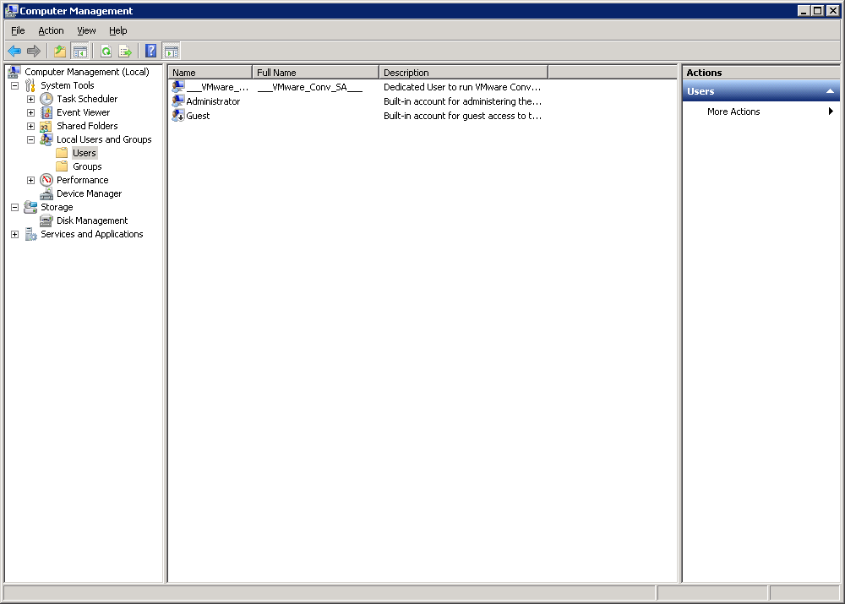

- Right-click on the user and choose “Set Password”
- Enter the new password in the field “New password”
- Repeat to input new password at “Confirm new password”
- Click the “OK” button

Computer System Operating (Abnormal)
This section mentions the operating procedures of performing the following tasks for operating staff under the computer systems BEEO-DMS, including:

  - Power Supply System Outage
  - Fault Report Procedure
  - First Line System Crash/Communication Fault Diagnosis

Power Supply System Outage
In case there is any scheduled power outage, the affected servers should be turned off properly in order to prevent unnecessary loss of data. Operating staff is required to follow the procedures mentioned in Section 6.1.1. Support Team should be notified prior to the scheduled power outage. On the other hand, users should also be informed and aware of the outage status.

Should there be the case of any unscheduled power outage, Uninterrupted Power Supply (UPS), which is connected with the servers, will cater for short-term electrical supply so as to maintain the running of the system for a short period. The affected servers should be turned off properly to prevent unnecessary loss of data. Operating staff is required to follow the procedures mentioned in 6.1.1. Support Team should also be informed of the outage status.

No matter the power outage is scheduled or not, operating staff is required to load the computer system, after the power supply has been resumed. (Refer to Section 6.3 for more details on loading the computer systems)

Fault Report Procedure
In order to report any faults and irregularities for BEEO-DMS, operating staff is required to follow the procedures mentioned below:

- Operators should report any computer operational problems to Support Team for further action or advice
- Per Support Team’s advisory, they should fix the problem themselves for recurrent minor issues, or they may call support from the hardware/software vendors concerned directly.

First Line System Crash/Communication Faults Diagnosis
    - System Crash Diagnosis Procedure
System failures may be due to server network disconnection, server hardware failure (e.g. harddisk, motherboard and RAM) and/or server operating system failure (e.g. crash of AIX operating system). Following are the diagnosis procedures:

- When a user cannot access BEEO-DMS application, the operating staff should firstly try with his/her own PC. If the problem exists only on user machine, check the network cabling for user.
- If a number of workstations cannot access the server, the operating staff should try to ping the server by opening the Command prompt and issuing the command “ping <server-ip>”. If the returned message looks like “Unreachable”, “Timeout” or “Unknown host”, some communication components might be mal-functioning. It is necessary to check the communication hardware (e.g. network port and switch placed near that group of users) and see whether there is any communication problem.
- If all workstations cannot access the server, the operating staff should try to ping the server by opening the Command prompt and issuing the command “ping <server-ip>”. If the returned message looks like “Unreachable”, “Timeout” or “Unknown host”, some communication components might be mal-functioning. It is necessary to check the communication hardware (e.g. hub or the network cards on the server) and see whether there is any communication problem.
- Gather the findings and error messages, if any, and report them to Support Team.
- For a major failure, where the system fails to respond to any key stroke, the operating staff should follow the procedures in Computer System Operating (Restart) (please refer to Section 8).
- If system crash occurs, Support Team should escalate to management as well as users if necessary.

Computer System Operating (Restart)
This section mentions the Reloading procedures for the servers. This should be referred whenever that server requires restart, e.g. after applying security patch. It may be necessary to shut down the system application before proceeding to restart of server.

Reloading Procedures
In order to restart the servers, at first, operating staff is required to follow the procedures of checking whether there is/are any batch job(s)/backup job(s) being run in that server (please refer to Section Error: Reference source not found).

After operating staff has verified that there are no batch job(s) or backup job(s) being run in the server, operating staff is required to follow the steps below in order to restart the server:

For Windows 2008 servers,
- Shut down the system application
- Click the “開始” button from the menu of the network operating system
- Select “關機”
- Select “重新開機” from the pull-down menu
- Click the “確定” button

After the above procedures have been followed, the server is going to be restarted. After a moment, a screen requesting the Console Administrator to login will appear. Then the Console Administrator/Operating Staff is required to logon the server and follow the procedures of “Loading the Computer Systems” mentioned on Section Error: Reference source not found.

Removable Media handling
This section describes the following areas:

  - Tape Deck Handling
  - Backup Tapes
  - Magnetic Tape Failure Recovery/Reporting
  - Labeling of Magnetic Tapes

Tape Deck Handling
To backup data form the server reliably, 3 sets of data tapes would be kept and each set would be responsible for 1 week’s backup. This leads to the retention period of the backup data be 3 weeks.

Tape drive is autoloaders. Thus operating staff is only required to change the set of tapes on the 1st daily backup of the week.

Backup Tapes
The backup tape used by backup should possess the following characteristics:

Format | LTO 5 Data Cartridge
Capacity | 1.5 TB or above

MAGNETIC TAPE FAILURE RECOVERY/REPORTING
Backup failure can be caused by either tape drive failure or tape failure. When backup fails, operating staff is requested to report to the support team and clean the tape drive to avoid the possibility of tape drive mal-functioning. If the error still occurs, operating staff should test the tape drive with a new tape and replace the damaged tape with a new one.

To avoid mal-functioning of tape drive, tape drive is recommended to clean monthly.

Labelling of Magnetic Tapes
In general, backup media is recommended to be labeled to ensure the data to be backed up to the correct tape.

    - Backup Tapes
Backup is performed at every night.

4 tapes are grouped into 1 set of backups. 1 set of backup tapes would serve 1 week’s data backup.

Rotation Scheme
This rotation scheme is designed to backup data for 3 weeks retention period.

 | Monday | Tuesday | Wednesday | Thursday | Friday | Tape Pool
Week 1 | Full | Incremental | Incremental | Incremental | Incremental | LTO000001 - 4
Week 2 | Full | Incremental | Incremental | Incremental | Incremental | LTO000005 - 8
Week 3 | Full | Incremental | Incremental | Incremental | Incremental | LTO000009 - 12

A total of 12 LTO 5 Data Cartridge will be required to implement the above backup scheme.

Off-Site Tape Arrange
1 set of weekly backup tapes should be stored off-site (Siu Ho Wan data center). It is suggested to bring the whole set of the weekly tapes to off-site weekly and call back when the set of tapes which are going to be used.

- End of Document -

